**Correlation Assignment Day 11**

**Step 1- Launching**

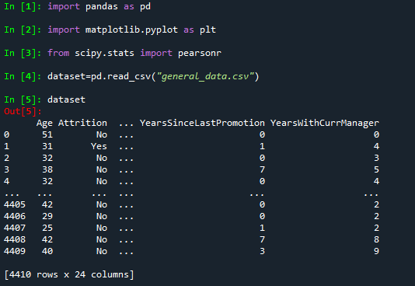

**Step 2- Data Treatment**

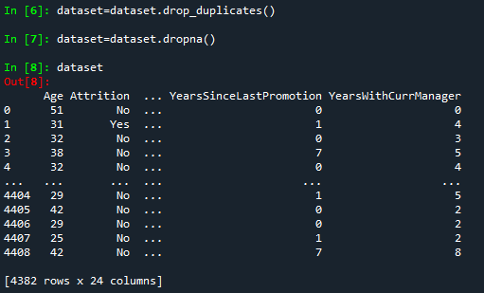

**Converted Attrition from No and Yes to 0 and 1.**



**Correlation between Attrition and Age-**

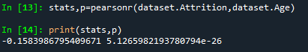

There is Low Negative Correlation between Attrition and Age.

**Correlation between Attrition and Distance from Home-**

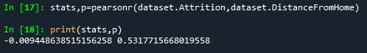

There is Low Negative Correlation between Attrition and Distance from Home.

**Correlation between Attrition and Education-**

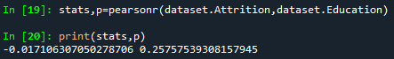

There is Low Negative Correlation between Attrition and Education.

**Correlation between Attrition and Job Level-**

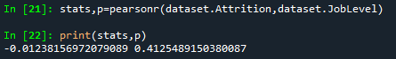

There is Low Negative Correlation between Attrition and Job Level.

**Correlation between Attrition and Monthly Income-**

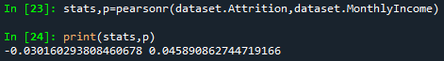

There is Low Negative Correlation between Attrition and Monthly Income.

**Correlation between Attrition and Training Times Last Year-**

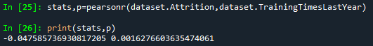

There is Low Negative Correlation between Attrition and Training Times Last Year.

**Correlation between Attrition and Years at Company-**

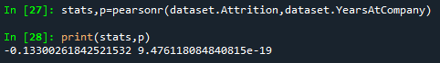

There is Low Negative Correlation between Attrition and Years at Company.

**Correlation between Attrition and Percent Salary Hike-**

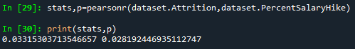

There is Low Positive Correlation between Attrition and Percent Salary Hike.

**Correlation between Attrition and Years with Curr Manager-**

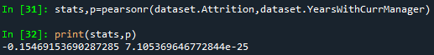

There is Low Negative Correlation between Attrition and Years with Curr Manager.

**Correlation between Attrition and Stock Option Level-**

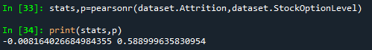

There is Low Negative Correlation between Attrition and Stock Option Level.

**Correlation between Attrition and Years Since Last Promotion-**

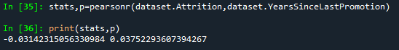

There is Low Negative Correlation between Attrition and Years Since Last Promotion.

**Correlation between Attrition and Num Companies Worked-**

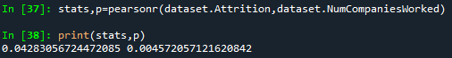

There is Low Positive Correlation between Attrition and Years Since Last Promotion.